

**AusWineApp Project**

**Business Requirements Report**

Version Number 1.0

|  |  |
| --- | --- |
| Title | Name |
| **WineCellarApp** | **Maxwell Barrah** |
|  |  |

Date: **16/06/2021**

## Executive Summary

This document explains the functional and non-functional requirements for the AusWineApp “WineCellar” project. This project consists of developing a partner app to the company’s current app called “WineFinder”. The WineCellar App is to allow its users to create their own personal digital wine cellar based off the wines in their collection. The app aims to allow users to incorporate current data from WineFinder. The app also aims to increase company wine data and create a better wine database for the app to provide to its users.

This document will also include any requirements needed to create the project as well as any methods used to collect data. The outcome of the report is to deliver a fully operational program with the correct requirements as per the client’s specifications, within the specified timeline.

**Table of Contents**

**Section Page No.**

Executive Summary 2

1 Introduction 1

1.1 Report Purpose 1

1.2 Client Details 1

1.3 Project Location 1

Stage 1 2

Stage 2 2

Stage 3 2

Stage 4 2

2 Opportunity Statement 3

3 Methodologies Used. 4

3.1 Methods for Data Gathering 4

3.2 Analysis Methodology 4

3.3 Findings: 4

4 System Requirements 5

4.1 Functional Requirements 5

4.1.1 Reason(s) for placement of the mandatory/optional line 5

4.2 Non-Functional Requirements 5

5 System Overview Use Case 6

Actor Descriptions: 6

5.1 UC01 Maintain Wine 7

7

5.2 UC02 List Wine 8

8

5.3 UC03 Cellar Utilities 8

8

6 Conclusion 9

7 Certificate of Acceptance 10

8 Bibliography 11

Appendices 1

Appendix A: Ease of Realisation 1

Appendix B: Final Rating 2

Appendix C: Data Domain Diagram 3

Appendix D: CRUD Table 1

# 1 Introduction

This document has been created to provide the respective diagrams and information regarding the technical and functional requirements of the project being developed by Big Brain IT for AusWineApp. This report will express what the features AusWineApp is wanting in the project, as well as outline the current work practices and methodologies used by Big Brain IT.

## Report Purpose

The purpose of this document is outlining the requirements needed to construct the new application for AusWineApp. This report is to outline the specifics, functions, technical requirements, and any other significant implementations requested by the client. And describe what the functions the client is requesting in the application.

## 1.2 Client Details

Brendon Merlot, a representative from AusWineApp approached us regarding developing their partner application to their current system. AusWineApp is a company that has been active for some time now, they specialize in wine, they deliver information about thousands of bottles of wine to its many users. The company is funded by the Wine Makers who pay AusWineApp to display information about their wines.

The Main ICT consultants actively working on the project are:

ICT Project Coordinator

Name: Maxwell Barrah

Phone: 0412345678

Email: max@max.com

## 1.3 Project Location

The Project is to be developed at Big Brain IT’s facilities and then be hosted and maintained at the same location. 1.3 Project Background

The current system is called WineFinder, and the service allows its users to get a range of different information about their current wine in their collection, or a wine that they have tasted and enjoyed or even any wine they see on the shelf. The information varies from basic to advanced.

The app allows for its users to access information on wine such as the type, availability, tasting notes, price. Some of the more advanced information is the regions, varietals, vintages, producers and the history of the wine. The application also allows for users to snap a photo of a bottle of wine and instantly be presented with that wine’s information. The application also allows for users to leave a review of the wine by entering tasting notes and score.

The project will undergo 3 stages of development finishing at the beta release.

* **Stage 1** Finalize all documentation and confirm requirements with client.
* **Stage 2** Prototype and begin development.
* **Stage 3** Have complete working beta.
* **Stage 4** Complete working version, ready for delivery

### **Stage 1**

This stage will include the finalizing of all reports and documentation in relation to the project. We will also be confirming the requirements of the project with the client before commencement of development.

### **Stage 2**

Prototypes of the project will be created as well as beginning the development of the project in order to deliver a December beta launch.

### **Stage 3**

The development of the project will be nearing completion of the beta stage with testing being conducted regularly in order to release beta by the beginning of December.

### **Stage 4**

Stage 4 is all about finishing the development. After development and testing and various other processes, the program will be ready for delivery to AusWineApp.

# 2 Opportunity Statement

AusWineApp is wanting to create a new application that will work alongside their current system WineFinder. This system will be a whole new interactive experience for the users allowing them to perform actions the current application does not provide. The company has a goal to increase the amount of companywide wine data, with a focus on the more experienced wine drinkers providing their wine data.

# 3 Methodologies Used.

## 3.1 Methods for Data Gathering

To be able to deliver a complete functioning program to AusWineApp we are going to be conducting several methods to gather the appropriate data.

* Review of Project Scope
* Review of other technical documentation
* Interviews with client for detailed information.

Using the listed methods an accurate Functional requirements document will be able to be produced with accurate listings of the Functional and Non-Functional requirements, ordered appropriately.

## 3.2 Analysis Methodology

Meeting minutes have been created to gather the appropriate information and feedback required to deliver the product AusWineApp is requesting. With the creation of the Requirements list that is attached in the document, this will need to be reviewed by the client with feedback to produce a complete Requirements list with priorities listed in order.

## 3.3 Findings:

Several functional requirements are required to be implemented for the AusWineApp project to be effective and function as intended. These requirements have been identified and are listed below.

* Manually Add new wine to cellar
* Add a wine using WineFinder
* Bulk-Import tool for existing data
* Barcode input for bulk updates
* Bulk Update/maintenance of consumed bottle
* Export data from for offline access/archive
* Generate printable wine-lists
* Ready to drink now list of wines by type
* List of wines by company, region and type
* List of your wines in your cellar in favorite order
* List of wines in your cellar past best use by
* Option to share wine rating information with the Wine AustWineApp web database

# 4 System Requirements

The tables attached present the functional and nonfunctional requirements of the project.

## 4.1 Functional Requirements

## 4.1.1 Reason(s) for placement of the mandatory/optional line

The optional line has been created with the items under optional to be implemented in a later stage. These items do not affect the users and users can operate app without these items initially.

## 4.2 Non-Functional Requirements

Items falling below the optional items are items that in this stage of development. The optional items will not affect the projects initial functionality. These items will be incorporated to the project later.

The listed Non-Functional requirements are separated from the Requirements list as required. These are to be added to the final project as according to the priority list. As per list the Non-Functional requirements are:

* Android App for beta release
* All information is stored in a database on the android device
* Share rating with AusWineApp database

# 5 System Overview Use Case

The provided Use Case diagram shows 2 Actors using 3 subsystems of the project.

# Actor Descriptions:

The system diagrams have 2 actors. One representing the AppUser and the other representing the WineFinder System. The AppUser will use all 3 subsystems, while the WineFinder only uses 1 subsystem.

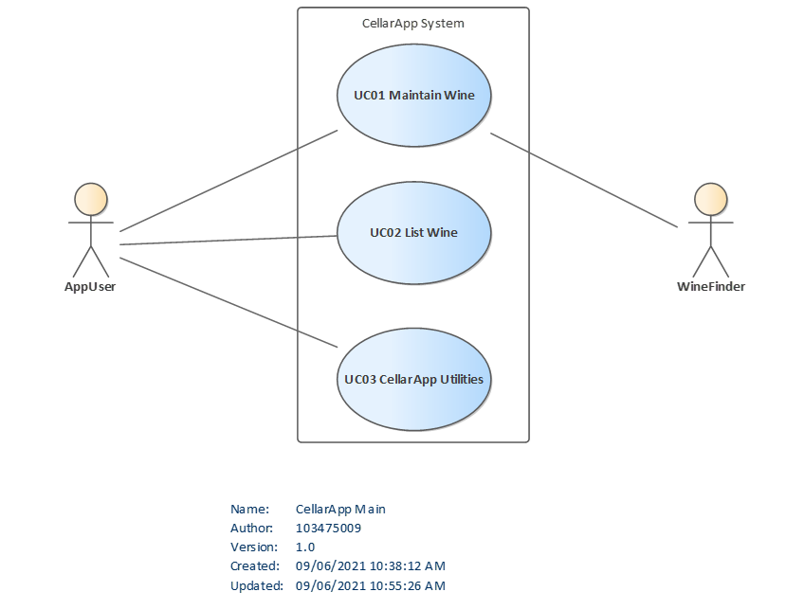

## 5.1 UC01 Maintain Wine

## 

## 5.2 UC02 List Wine

## 

## 5.3 UC03 Cellar Utilities

## 

# 6 Conclusion

In conclusion the project is producible to the initial requirements given by AusWineApp. The only constraints will be time. With the priority list we have learned the importance of each technical requirement and the order of development and implementation. An example of the order of development will begin with developing firstly Manually Add new wine to cellar, followed by Add a wine using WineFinder, then followed by Bulk-Import tool for existing data.

The listed 12 functional and nonfunctional requirements listed above with 10 being functional, and 2 being nonfunctional, those nonfunctional requirements being Export data from for offline access/archive and Option to share wine rating information with the Wine AustWineApp web database. 3 Subsystems have also been identified, First sub system is Maintain Wine, Second Subsystem is List Wine, and thirdly CellarApp Utilities.

Upon completion of documentation and finalizing the requirements with the client we can progress to the second stage of development. Once prototyping and development has commenced, we will be on course for the third stage of development which is to have a beta released by the start of December.

# 7 Certificate of Acceptance

The signatures below approve the requirements and functions listed in this document are suitable for the AusWineApp Project.

|  |
| --- |
| Client: **Brendon Merlot, AusWineApp Representative**  Signature………………………………………………..………………….. Date: …./…./…… |
|  |
| Team Leader: **Maxwell Barrah, Team Leader**  Signature…………………………………………………..……………….. Date: …./…./…… |

# 8 Bibliography

1. ‘ICT_BusinessRequirements_Template.docx , ICT Document Templates, 2020’

2. ‘AustWineApp Meeting Recording 1 June 2020’

3. ‘MeetingMinutes_MaxBarrah.docx’

4. ‘Project_Charter_AusWineAppMaxBarrah.doc’

# Appendices

# Appendix A: Ease of Realisation

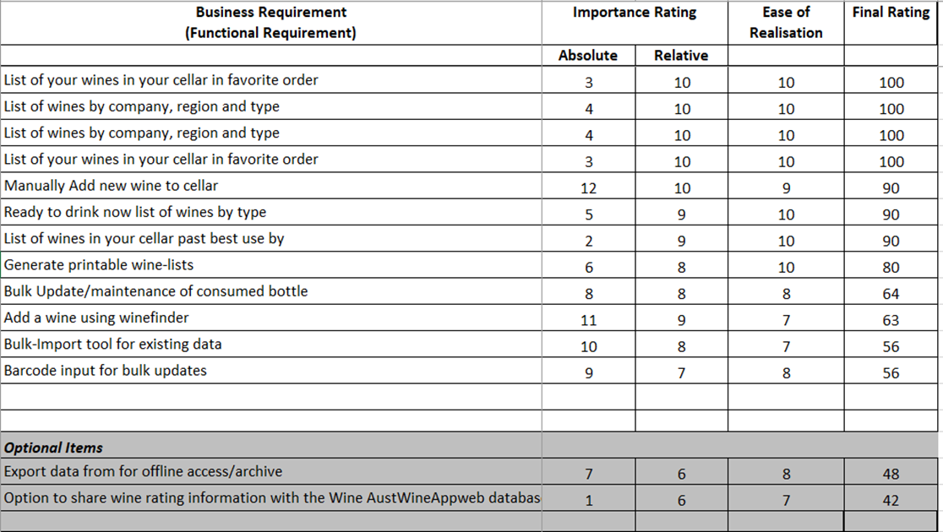The last field is for the final rating of the listed requirements that have been calculated.

## Appendix B: Final Rating

## Appendix C: Data Domain Diagram

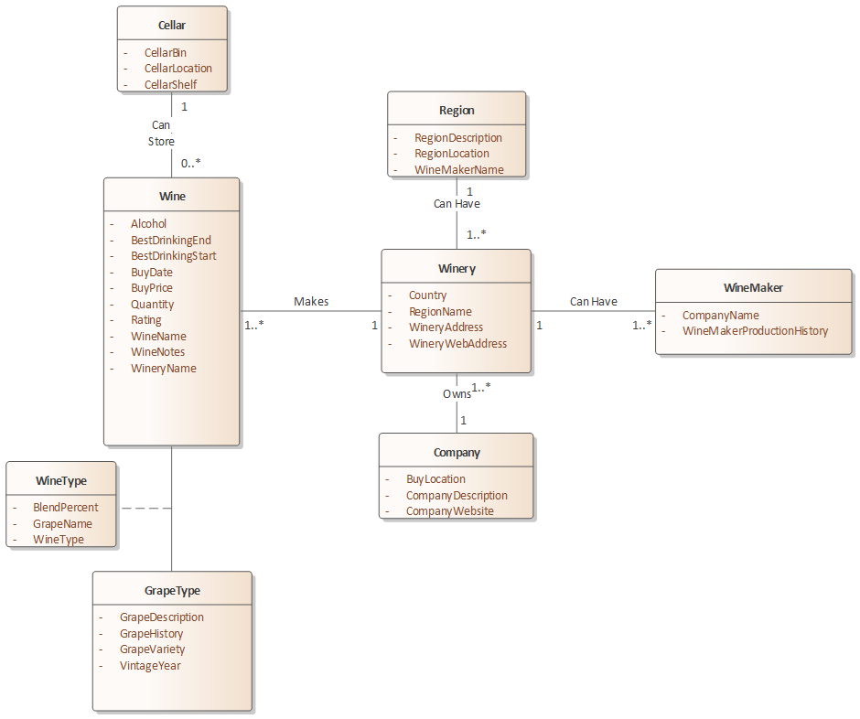

## Appendix D: CRUD Table

|  |  |  |  |  |  |  |  |  |  |
| --- | --- | --- | --- | --- | --- | --- | --- | --- | --- |
| **Classes** | ***Wine*** | ***CellarLocation*** | ***GrapeType*** | ***Winery*** | ***WineMaker*** | ***Company*** | ***Region*** |  |  |
| **Initial Use Cases** |  |  |  |  |  |  |  |  |  |
| UC01 Manually Add Wine | C | RU | R | RC | RC | RC | RC |  |  |
| UC02 Add Found Wine | C | RU | R | R | R | R | R |  |  |
| UC03 Import Wine Data | C | RU | R | RC | RC | RC | RC |  |  |
| UC04 Export Data | R | R | R | R | R | R | R |  |  |
| UC05 List All Wine | R | R | R | R | R | R | R |  |  |
| UC06 List Ready to Drink | R | R | R | R |  | R | R |  |  |
| UC07 List by Region and Type | R | R | R | R |  | R | R |  |  |
| UC08 List Favorites | R | R | R | R |  | R | R |  |  |
| UC09 List Best Use by | R | R | R | R |  | R | R |  |  |
| UC10 Bulk Updates Via Barcode | RU | RU | R | R | R | R | R |  |  |
| UC11 Bulk Update of Consumed Wine | RU | R | R | R | R | R | R |  |  |
| UC12 Share Wine Information | R | R | R | R | R | R | R |  |  |
| **NEW USE CASES** | D | CD | CUD | UD | UD | UD | UD |  |  |
| UC13 Maintain Cellar |  | CRD |  |  |  |  |  |  |  |
| UC14 View Wine | R | R | R | R | R | R | R |  |  |
| UC15 Find Wine | R | R | R | R | R | R | R |  |  |
|  |  |  |  |  |  |  |  |  |  |